**Be sure AirDrop is turned on by swiping down from the top right corner of the iPad (or swiping up on an iPhone). Look for the AirDrop icon 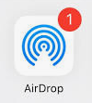 and set to “everyone.” OR, go to Settings>General>AirDrop>Everyone.**

